**EXPERIMENT 3**

RELATIONAL MODEL FOR COLLEGE DATABASE

**Aim:** Draw a relational model for college database

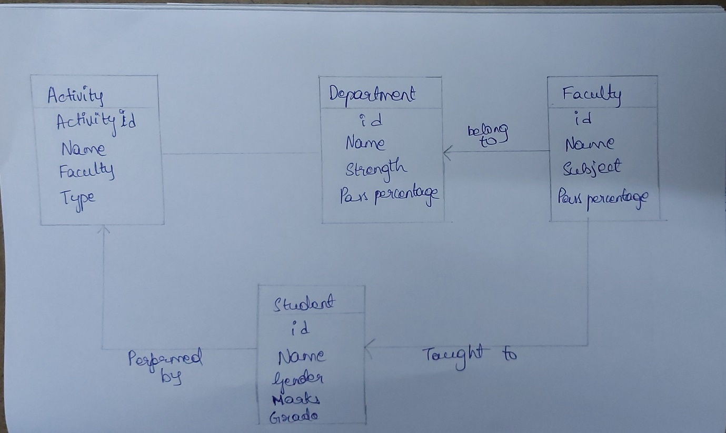

id

name

subject

passPercentage

**Activity**

**Faculty**

Belong to

Sid

Sname

Address

Dob

PhNo

age

Id

name

faculty

type

Taught to

Performed by

**Student**

id

name

strength

PassPercentage

**Department**